LAB 01
- 1. Establish a local repository for your project with a descriptive name. Set up Git configurations by adding a username and email address.
Display and modify the Git configurations, and verify if the changes are reflected in the. git/config file post-editing. Showcase the utilization of both Git Local and Global configurations.

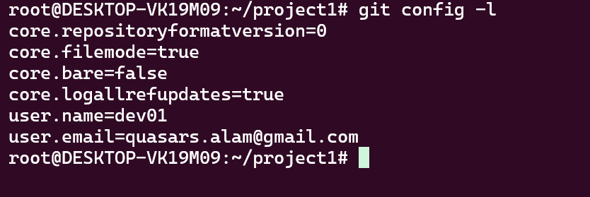
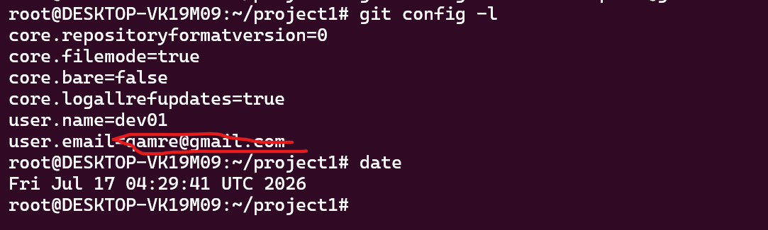
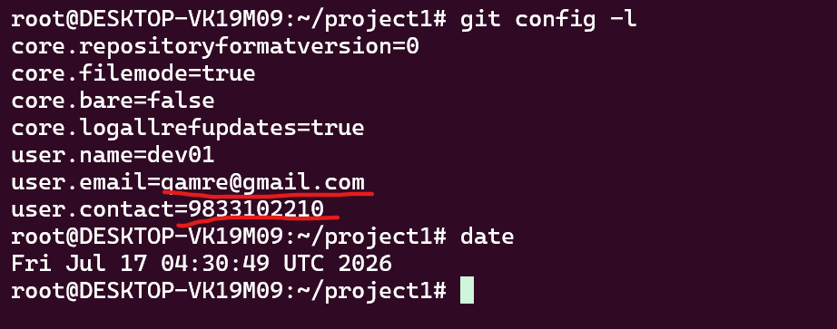

2. Set up a local repository for your project with a meaningful name. Explore the default branch in the local Git repository. Sequentially create five files, committing each with informative messages. Share the Git log output through multiple methods once the process is complete.

-rw-r--r-- 1 root root 15 Jul 17 04:33 file1.txt
-rw-r--r-- 1 root root 15 Jul 17 04:33 file2.txt
-rw-r--r-- 1 root root 15 Jul 17 04:33 file3.txt
-rw-r--r-- 1 root root 15 Jul 17 04:34 file4.txt
-rw-r--r-- 1 root root 15 Jul 17 04:34 file5.txt

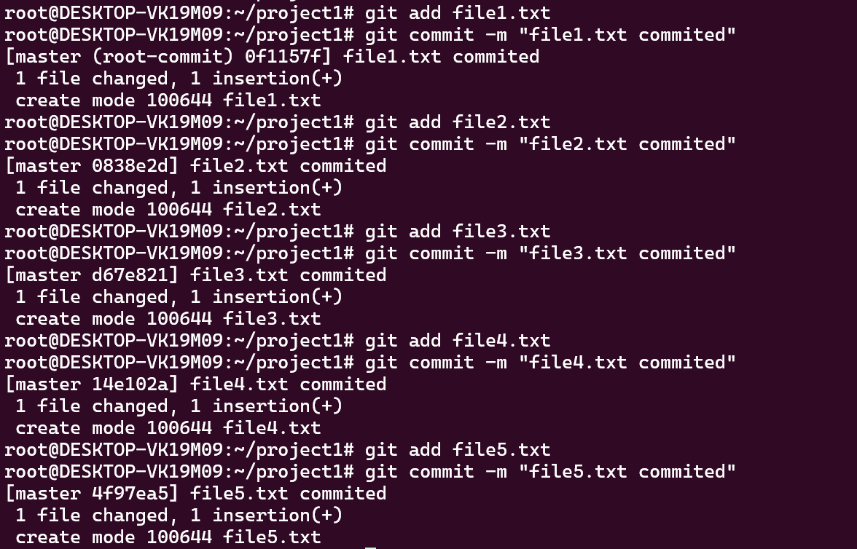

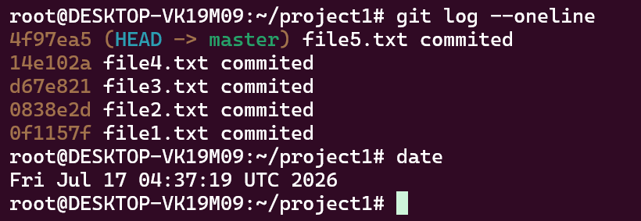

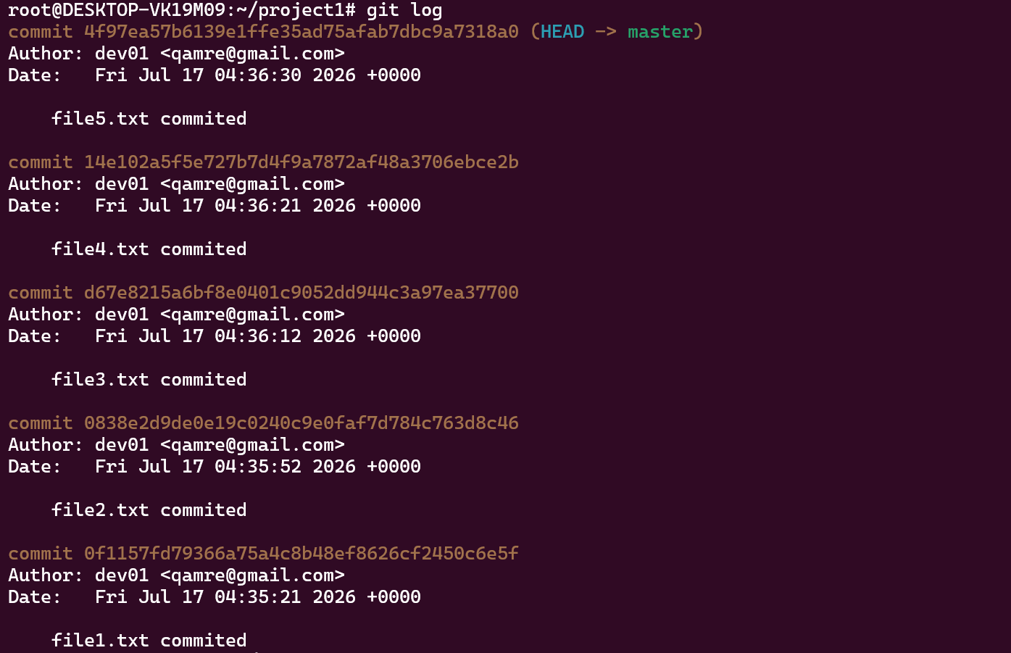
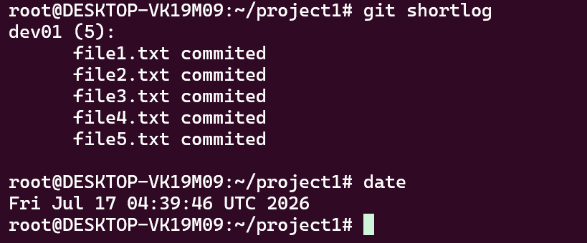
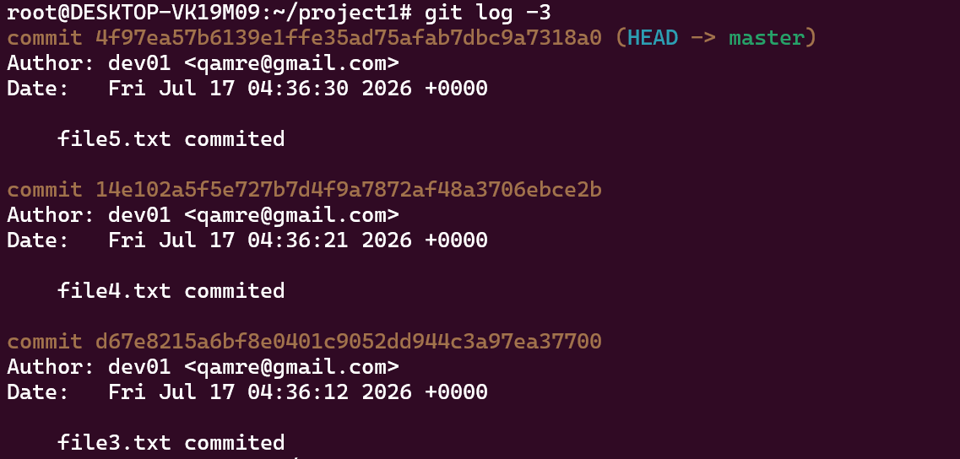

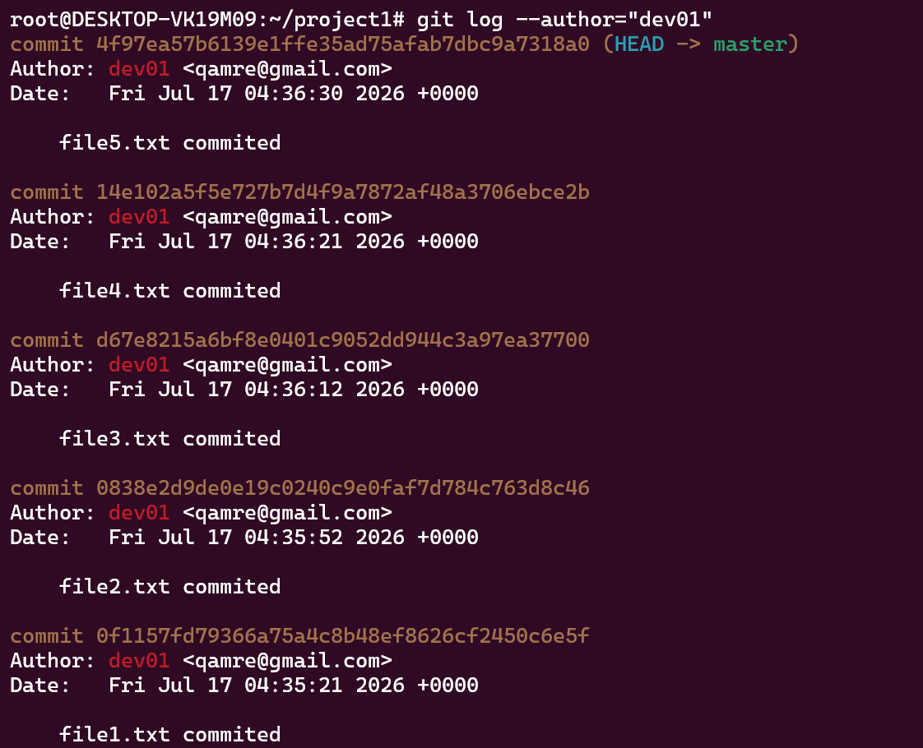

3. Open a GitHub account and initiate a remote Git repository. Examine the default branch in the remote repository. Create and commit the following files one by one with meaningful commit messages:
i. README.md
ii. send_disk_alert.sh
iii. create_users.sh
iv. check_service.sh.

Repos name :- lab-01-repository
Default main branch
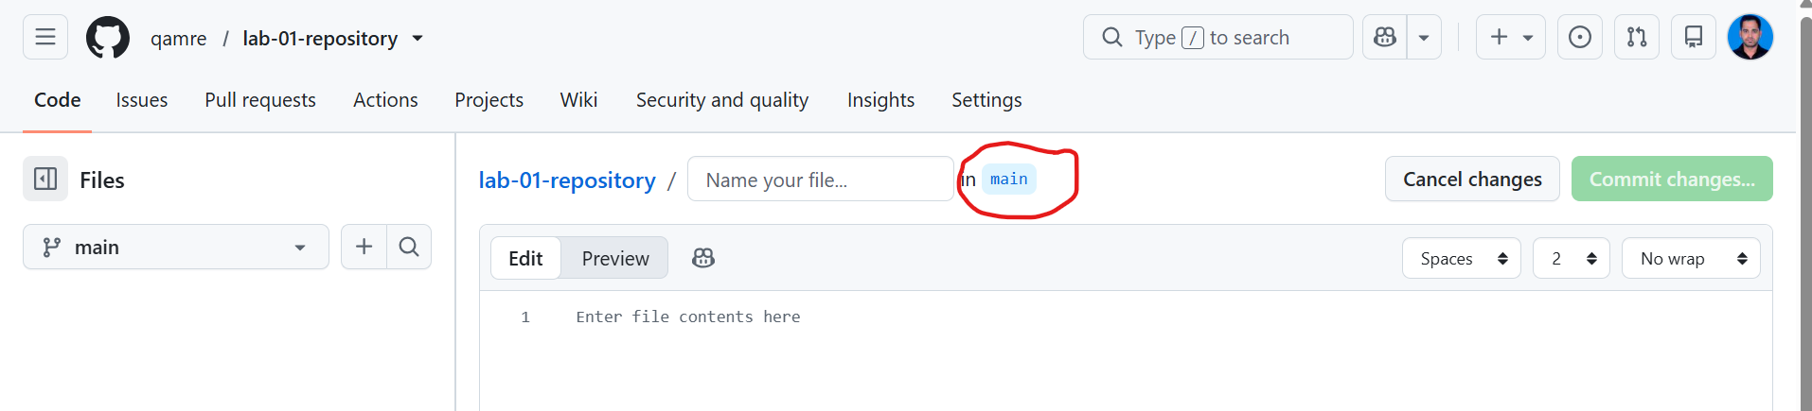
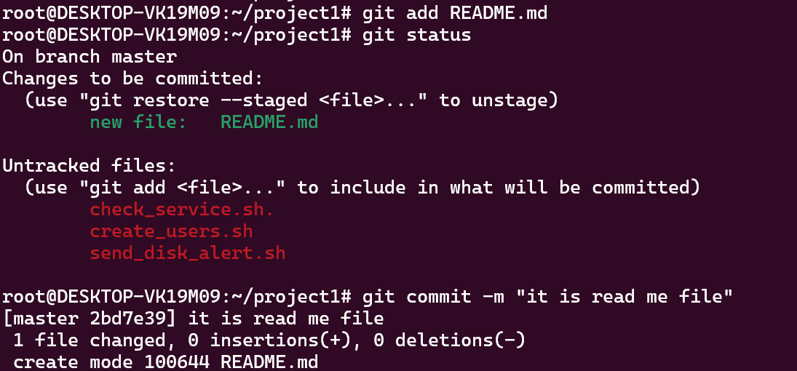
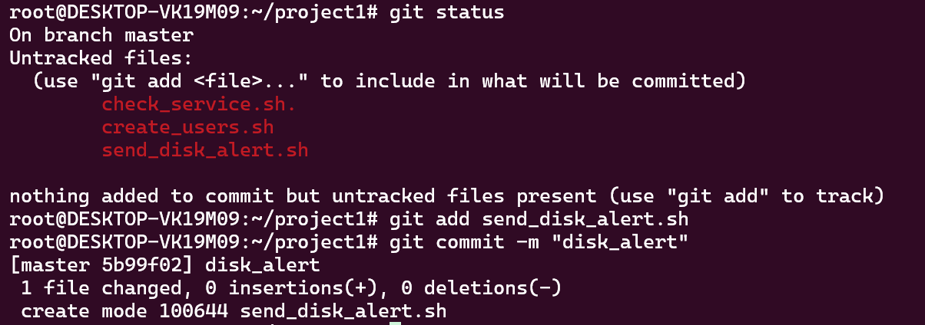
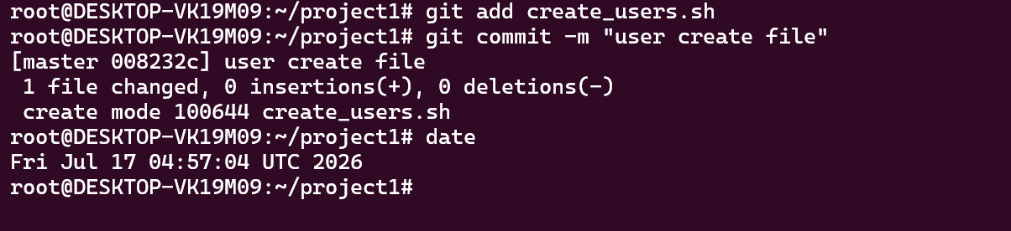
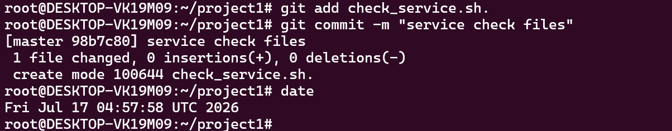

4. Establish a local repository for your project with a descriptive name. Illustrate the implementation of a Git-Ignore file by committing multiple files to the local repository.

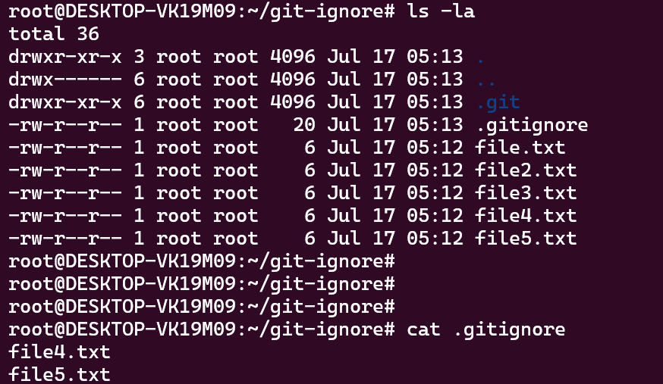
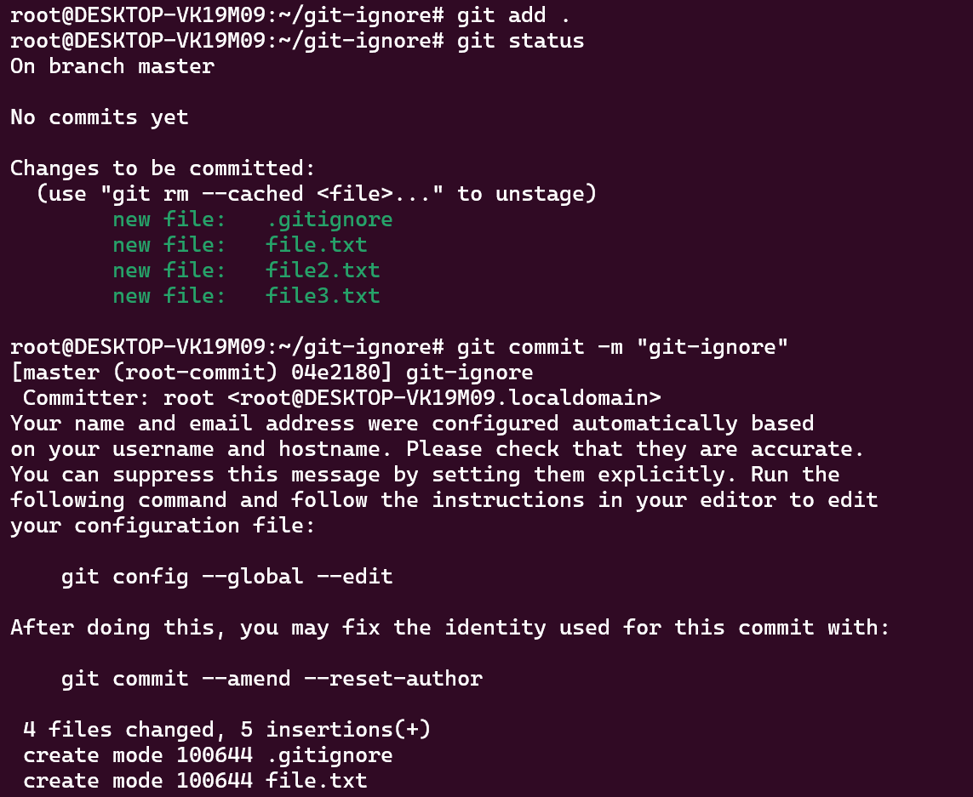
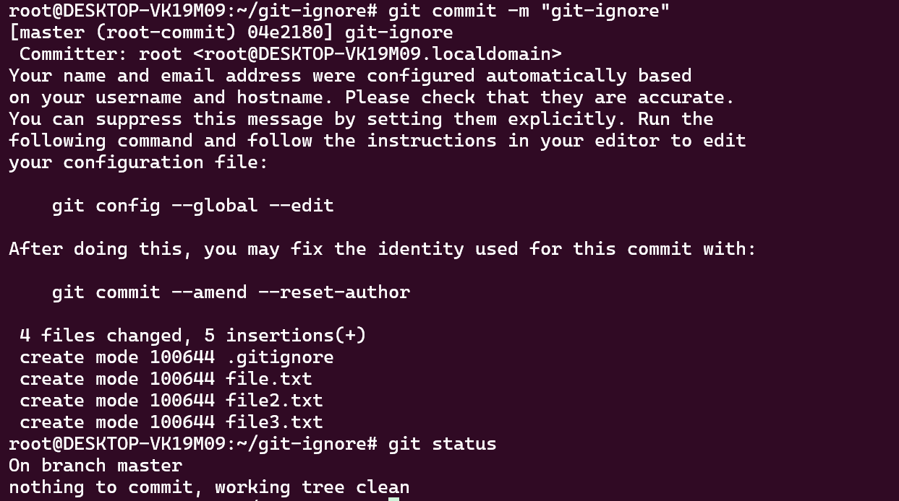

5. Create a local repository with a meaningful project name. Demonstrate the utilization of GIT working area, staging area, and commit area. Experiment with committing, deleting, and restoring files from the repository. Additionally, add files to the staging area and restore them from the staging area.

Project name: - git-demonstration

working area :- Working area is which is local for the working user which is not know by the git till you add the file into the git by the git add command. Till you do not run git add command till the git is not aware that the git have need to manage and track the file changes.

Staging area: This is the are from where the git start tracking the file once commit done by the developer. Once the developer run git add command then after it get to the staging are from which the git start tracking changes of the files.

Commit area: is the area where the final commit have been save after all the changes and approvals.

Committing a file
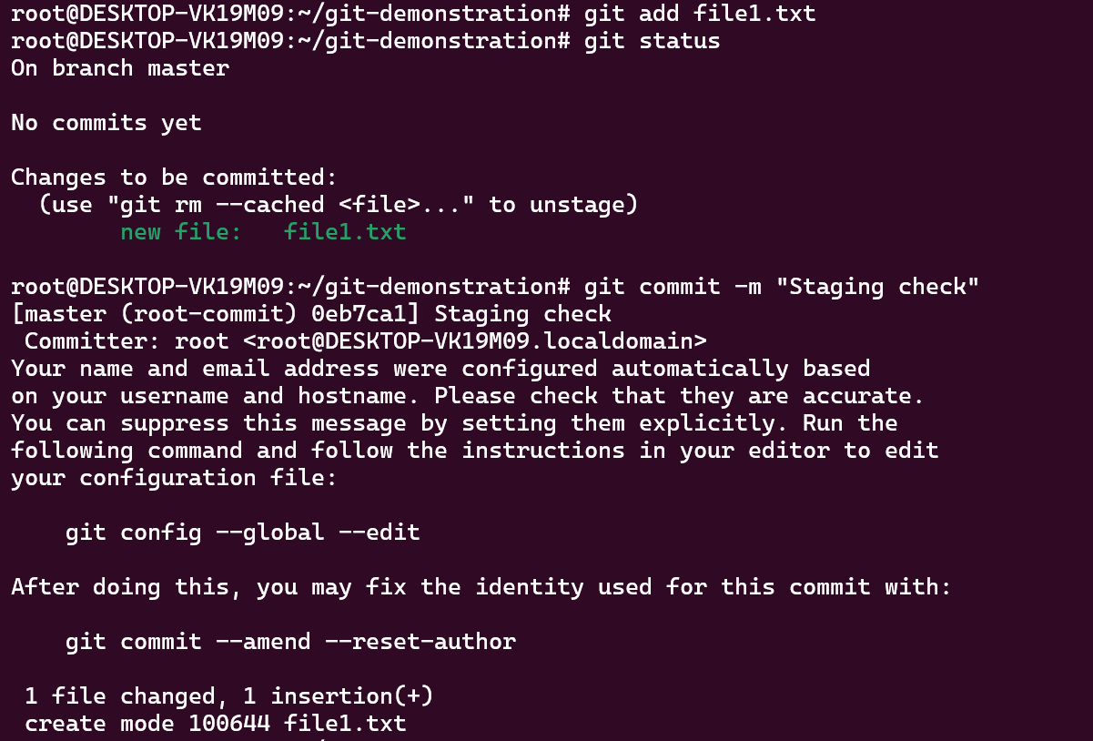

Deleting local file and restoring form the staging area.
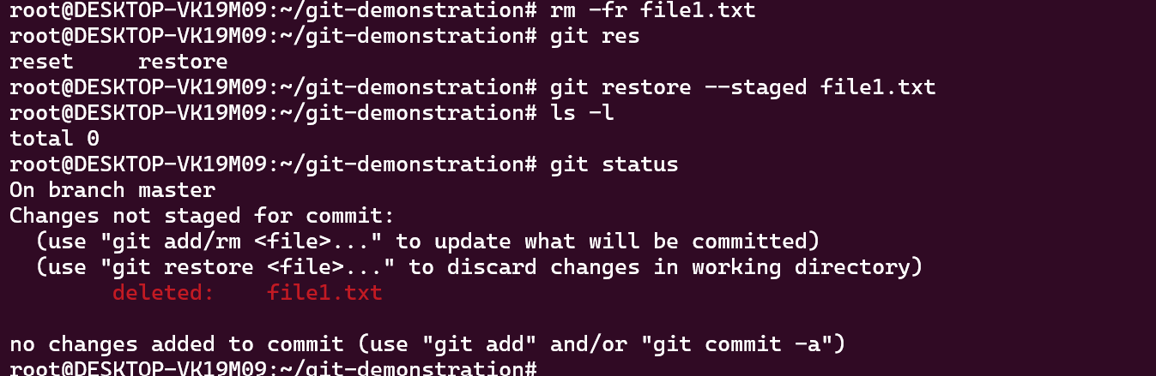

- File2.txt restore from the repository area
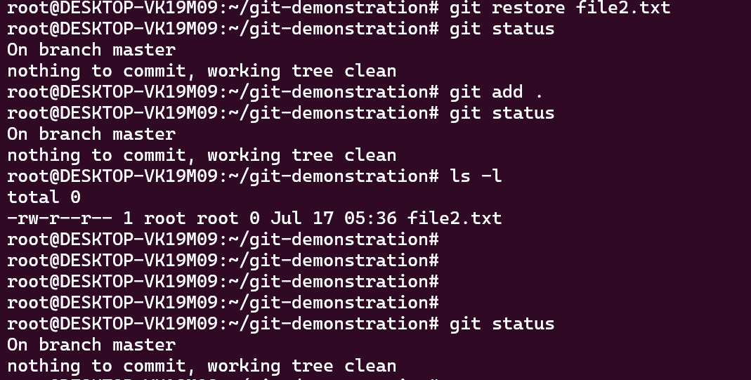

Dought : after restoring from the staging it is visible in git status as deleted firl. What about restore fire form the final commit from the staging area
===========================================================================

echo "# lab-01-repository" >> README.md
git init
git add README.md
git commit -m "first commit"
git branch -M main
git remote add origin https://github.com/qamre/lab-01-repository.git
git push -u origin main

…or push an existing repository from the command line
git remote add origin https://github.com/qamre/lab-01-repository.git
git branch -M main
git push -u origin main

